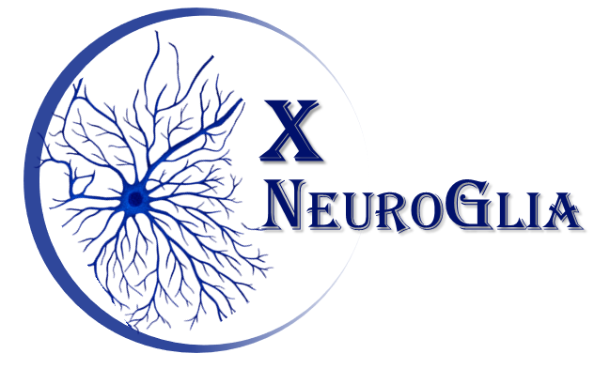 | International Symposium of Neurochemistry and Physiopathology of Glial Cells  Institute of Sciences of Health, Federal University of Bahia  Salvador – Bahia - October 26st to 28th 2026

DETAILED PROGRAM

# 26/10/2026 (Monday)
08:30- 12:30 Opening X NeuroGlia
08:30- 12:30 Session 1 - Glial Cells Function and Dysfunction
Lecture 1 - Maria Trinidad Herrero Esquerro (Universidad de Murcia, Espanha)
Lecture 2 - Dulce Papy Garcia (Université de Paris Est Creteil, França)
Lecture 3 - Patrick Pierre Michel (Institut du Cerveau Paris, França)

Lunch Break

14:00 - 16:30 – Session 1 - Glial Cells Function and Dysfunction I
Lecture 4 – In the search of protective compounds for macroglial cells and macroglial cells-neuron communication. Silvia Oliveira Bravo (Biological Research Institute Clemente Estable – IIBCE, Uruguay)
Lecture 5 Rommy Von Bernhardi (Universidad of San Sebastián, Chile)
Lecture 6 Flavia Alcantara Gomes (Federal University of Rio de Janeiro)

16:30 25 Year LabNq - Silvia Lima Costa e Maria de Fátima Dias Costa

# 27/10/2026 (Tuesday)
08:30- 12:30- Session 2 - Drug Development Technology and Therapy for Neurological Disorders I
Lecture 7 - George Emiliano Barreto (University of Limerick, Irlanda)
Lecture 8 - Victor Diogenes Amaral da Silva (Federal University of Bahia)
Lecture 9 – Irlã Santos Lima (Federal University of Bahia)
Lecture 10 – Fernanda Vidal (Federal University of Bahia)

Lunch Break

14:00-18:00 – Session 3 - Drug Development Technology and Therapy for Neurological Disorders I
Lecture 11 - The intersection between Type 2 Diabetes and Alzheimer's Disease: Response of glial cells and cerebral endothelium to metformin. Flavia Eugenia Saravia (Universidad de Buenos Aires, Argentina)
Lecture 12 - Alexandre Moraes Pinheiro (Federal University of Recôncavo da Bahia)
Lecture 13 - Foodomics, functional breads, and the gut-brain axis. Marco Lazo Vélez (Universidad del Azuay, Equador)
Lecture 14 – Balbino Lino dos Santos (Universidade Federal do Vale do São Francisco)
Lecture 15- Juciele Valeria Ribeiro de Oliveira (Federal University of Bahia)

# 28/08/2025 (Wednesday)
09:30- Session 5 - Psychoactive Substances and Mental Health
Lecture 16 – The impact of medicinal cannabis use. Antonio Andrade (Neurology and Neurosurgery Foundation Salvador-Bahia)
10:30 -12:30 Poster Section

Lunch Break

14:00 - 16:30 – Session 5 - Psychoactive Substances and Mental Health
Lecture 17 – Focus on schizophrenia and major depressive disorder. Eduardo Pondé (Federal University of Bahia).
Lecture 18 – Psychedelics and brain identity: dynamic network signatures under DMT and Ayahuasca. Thaise Toutein (Federal University of Bahia)
Lecture 19- Denis
16:00 Prizes and Closuring

